SAFEGRID-AI: AN EXPLAINABLE MULTI-AGENT SYSTEM FOR DYNAMIC POWER ROUTING
Scope and Limitations
Department of Computer Science and Engineering, TKR College of Engineering and Technology (Autonomous)
Batch A13 (CSE-A) · Academic year [ACADEMIC YEAR]
Table 1: Project team
S.No. | Student name | Roll number
1 | DISHA KAUSHAL | 23K91A0563
2 | BOLLAM RAKESH | 23K91A0542
3 | CHINNOLLA RAVINDHAR | 23K91A0554
4 | AFFAN MOHAMMED RAMY | 23K91A0505

Project guide: CHANDRASHEKAR
Chapter and section numbers quoted in the text (for example Section 6.6 or Chapter 8) refer to the full project report, 17.Final Document. Figures and tables in this document are numbered from 1.

1. SCOPE

1.1 In Scope
• Simulated network. A three-node low-voltage feeder behind a 20/0.4 kV, 0.25 MVA transformer, solved with an AC power flow (pandapower [11]) every 15 minutes of simulated time.
• Agents. Three agents (residential prosumer with 6 kWp PV and a 10 kWh battery; EV storage node with a 40 kWh battery, charge only, 7.4 kW; renewable prosumer with 20 kWp PV and a 30 kWh battery) that perceive a structured context and propose one action per step.
• Actions. Seven action types: charge, discharge, import, export, curtail generation, shift load and idle, under a closed schema.
• Safety. Ten ordered checks, three verdicts (approved, projected, rejected), configurable limits and a hash-chained audit log.
• Scenarios. Seven seeded scenarios: normal, high solar, peak demand, battery stress, line congestion, voltage violation and unsafe AI action.
• Providers. A deterministic mock, a rule-based baseline, a failing provider for tests, a fault-injecting provider and an API provider for a hosted model, any of which may fail into a labelled fallback.
• Interfaces. A REST and WebSocket API and a React console with seven screens, a landing page and a demo sign-in.
• Evaluation. An experiment runner for three strategies, and results stored in SQLite.
Table 2: Scope by dimension
Dimension | Included | Excluded
Network | 3 nodes, 4 buses, 3 lines, 1 transformer; single-phase equivalent | Meshed, three-phase or larger networks
Time | 15-minute quasi-static steps; runs of 12 to 32 native steps (24 in the experiment) | Seconds-scale dynamics, protection
Control | One action per agent per step, seven action types | Multi-step plans executed without re-validation
Safety | Voltage, line, transformer, battery, node and grid import/export limits | Frequency, harmonics, short-circuit levels
Data | Seeded synthetic profiles | Measured profiles, forecasts
Models | Deterministic mock; API provider implemented | Evaluated hosted models; training or fine-tuning
People | Developer browser walk-through | User studies

1.2 Out of Scope
• Real hardware, field data or any connection to a real network.
• Protection, fast dynamics, frequency control, harmonics and three-phase unbalance.
• Forecasting, electricity markets and real tariffs (a time-of-use tariff of 3.8 to 9.0 INR per kWh is illustrative).
• Training or fine-tuning of a language model, and evaluation of a live hosted model.
• Authentication, authorisation and transport security of the API; the demo sign-in is a browser-side gate only.
• User studies and usability evaluation.
• Formal verification of the shield.

1.3 Intended Users and Use
The intended users are students, instructors and researchers who want to study how an autonomous proposer behaves under a safety layer. The intended use is simulation, teaching and comparison of controllers. The software is not intended to control, and must not be connected to, real distribution equipment.

1.4 Deliverables
The deliverables are the source code (3,117 lines of backend, 624 lines of tests and 6,989 lines of frontend), the run scripts, the documentation set, the 63-run result file and the screenshots and diagrams used in the reports. Everything runs on one ordinary computer without a graphics processor, and the backend and frontend start with one script (run.bat).
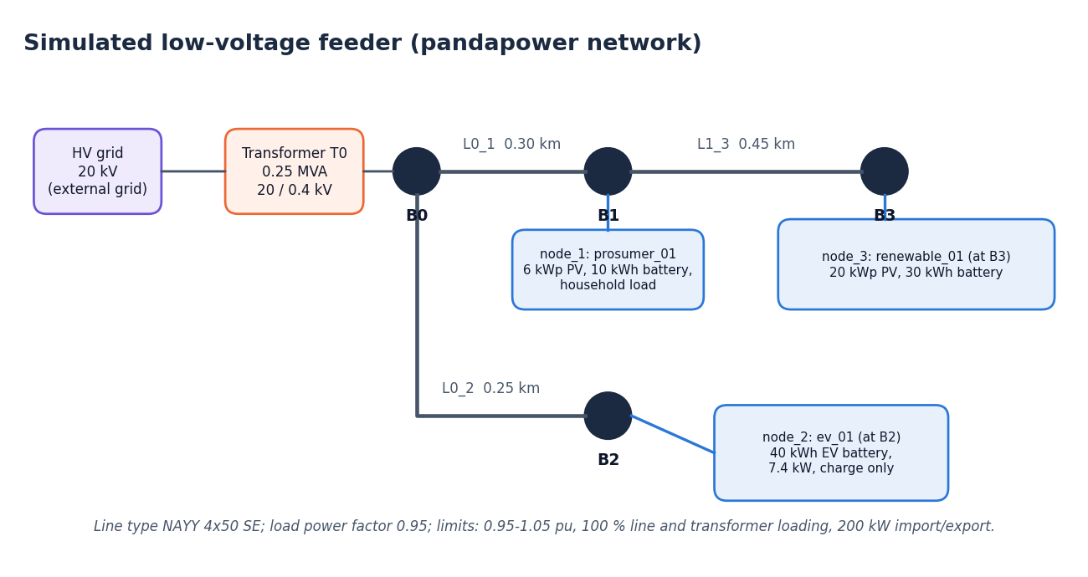
Figure 1: The simulated feeder that bounds the scope of every result

2. ASSUMPTIONS
The results depend on the following assumptions, all of which are built into the simulator or the experiment:
• Quasi-static operation. Each 15-minute step is solved as a steady state; dynamics inside the step are ignored.
• Single-phase equivalent. The feeder is balanced; load power factor is 0.95; line type NAYY 4x50 SE.
• Perfect observation. Agents receive exact node state, prices and a weather label; there is no measurement noise or communication delay.
• The simulator is the truth. The shield judges an action by what the simulated power flow says; if the model were wrong, the shield would protect the wrong limits.
• Synthetic inputs. Solar follows sin^1.2 between 06:00 and 18:00 scaled by a seeded cloud factor of 0.45 to 1.0; household load has a morning and an evening bump with 5 % seeded noise; the tariff and the export credit (60 % of the import price) are illustrative.
• Monotone safety. Bisection assumes that scaling an action down never makes it less safe; the defensive re-verification of the final rounded action guards against small violations of this assumption.
• Limits come from configuration. 0.95 to 1.05 pu, 100 % line and transformer loading, 200 kW grid import and export; the voltage band is of the kind used in public-network standards [19].
• A mock stands in for the language model. The deterministic, seeded provider produces plausible proposals with occasional over-sizing; real models will behave differently.
Table 3: Numerical assumptions and what changes if they are wrong
Assumption | Value used | If it were different
Voltage band | 0.95 to 1.05 pu | A tighter band raises the intervention rate and the cost of safety
Line and transformer limit | 100 % of rating | A lower operating limit needs only a new constraint file
Grid import and export limit | 200 kW | Not reached on this small feeder in the reported scenarios; a much lower value would bind
Smallest useful action | 0.05 kW | Larger values turn more projections into rejections
Implausible-request factor | 5 x node rating | Smaller values reject large but possibly valid requests
Power-balance tolerance | 0.05 kW | Looser values hide errors in the power flow
Control step | 15 minutes | Longer steps make the quasi-static model less accurate
Mock over-sizing | Seeded, scenario-dependent rates of unsafe proposals | A different rate changes the size of the unshielded harm, not the shielded result

Each of these is a configuration value, not a constant buried in a check, so a different assumption can be tested by editing the constraint file or the run configuration. The experiment used the defaults shown.

3. LIMITATIONS
8 limitations affect how the results may be read. Each is stated with its consequence.

3.1 No live language model
Limitation. Every agent result comes from the deterministic mock provider; no live language model was evaluated, so language-model reasoning quality and real inference latency are unmeasured.
Consequence. Language-model reasoning quality, robustness to prompts and real inference latency are all unmeasured. The measured benefit of the shield is the benefit against a mock that over-sizes requests on purpose, so it is likely an indication, not an estimate, of the benefit against a real model.

3.2 No violation-resolution rate
Limitation. The batch objective 'violation resolution rate' was not measured; the project measures violations prevented (caused by actions = 0) and steps with any violation, not repair of a grid that is already outside its limits.
Consequence. The project cannot say how often unsafe proposals are repaired when the grid is already outside its limits. It can say only that actions do not make things worse. The peak_demand result shows that, there, the rule baseline leaves fewer violation steps than the shielded agents.

3.3 Decision latency is not representative
Limitation. Mean decision latency is 0.1-0.2 ms for the mock provider and says nothing about a real model.
Consequence. The 0.17 ms mean decision latency in the tables must not be read as the latency of an AI planner; with a hosted model it would be orders of magnitude larger and would dominate the step time.

3.4 Small synthetic experiment
Limitation. Three seeds, a three-node synthetic feeder, an illustrative tariff, no protection, no dynamics and no three-phase unbalance.
Consequence. Three seeds give means but not meaningful confidence intervals; the feeder has three nodes, so effects such as congestion are exaggerated compared with real networks and phenomena such as unbalance are absent. Absolute costs in INR are illustrative.

3.5 Model-relative guarantee
Limitation. The guarantee is model-relative (no new or worse violations in the simulated model), not a formal proof; the abstract's 'mathematically guaranteeing zero physical constraint violations' is stronger than what was built and tested.
Consequence. The shield's guarantee is that executed actions create or worsen no violation of the configured limits in the simulated model. It is neither a formal proof nor a promise of a violation-free grid. The wording of the abstract ("mathematically guaranteeing zero physical constraint violations") is stronger than what was built or tested.

3.6 Qualitative comparison with the base paper
Limitation. The comparison with the base paper is qualitative: different system, no shared benchmark, no like-for-like numbers.
Consequence. No number from this project can be compared with the base paper's. Statements about advantages over it are statements about design, not about measured performance.

3.7 Failing and hanging tests
Limitation. Two unit tests fail on numeric tolerances with pandapower 3.5.6 and one WebSocket test hangs under the installed Starlette test client.
Consequence. Test code defects reduce confidence in the regression suite: the two grid tests fail on numeric tolerances with pandapower 3.5.6, and the WebSocket test hangs. They do not affect the experiment results, which come from the engine, but a green suite would be better evidence.

3.8 No user study
Limitation. No user study was carried out, so usability and operator trust are not measured.
Consequence. Whether operators find the explanations clear, and whether they trust or over-trust the shield, is unknown.

3.9 What Would Change the Conclusions
Four findings would change the conclusions if they came out differently. First, a real language model that routinely produces schema-valid but plainly unreasonable proposals would push the intervention rate far above the measured 23.2% and would make the cost of safety (compute and renewable utilisation) the main question. Second, a trial power flow that disagrees with a more detailed network model would show that the shield enforces the wrong limits. Third, a user study in which operators over-trust the shield's "approved" label would show that the interface, not the algorithm, creates the risk. Fourth, a test of the bisection on non-monotone cases that returns an unsafe value would show that the defensive re-verification is not enough.
None of these has been observed, and none has been tested, which is why the guarantee is stated as model-relative and why the report prefers the wording "no new or worse violation in the simulated model" to "zero violations".

3.10 How to Read the Numbers
The numbers in the report are measurements of a specific simulator. Three habits keep them in proportion. First, read the per-scenario tables before the overall means: the overall mean mixes a scenario in which nothing happens with one in which most proposals are changed. Second, read the attribution metric and the counterfactual together: 0 violations caused is meaningful because the raw proposals would have caused 192 violations in 145 steps. Third, treat the cost, renewable-utilisation and latency figures as indications of direction and order of magnitude, not as predictions for a real feeder or a real model.
The chart below shows the largest limitation of the guarantee: grid stress that exists with every agent idle is not removed by the shield.
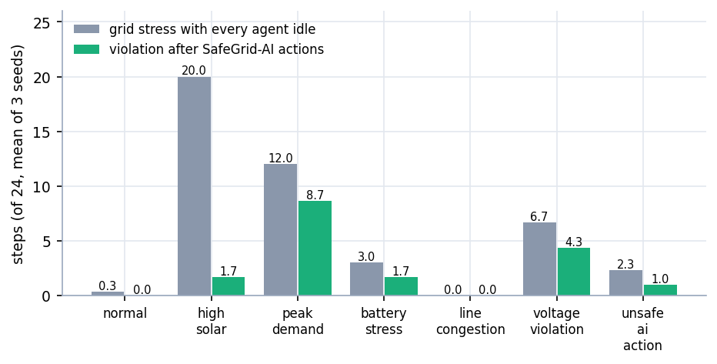
Figure 2: Grid stress with every agent idle compared with violations after SafeGrid-AI actions (steps of 24, mean of three seeds)

4. WHAT WAS NOT MEASURED
Honest reporting means listing what was not measured. The table gives each item, the reason, and what would be needed.
Table 4: Quantities not measured
Quantity | Why it was not measured | What would be needed
Accuracy, F1, precision, recall, confusion matrix | Not applicable: there is no dataset, no trained model and no classification task; inputs are generated from a seed | Nothing; these metrics do not apply to this project
Real language-model latency and cost | No API key was configured; the provider was run only in its unconfigured and mocked paths | A hosted model, a key and a repeat of the experiment
Violation resolution rate | The evaluation measures violations prevented and steps with any violation, not repair of pre-existing violations | A resolution metric and a planner that is rewarded for resolving
Quality of language-model reasoning | The mock is a transparent heuristic with seeded over-sizing | Evaluation with real models
Performance on standard test networks | Only the three-node feeder was modelled | IEEE and CIGRE feeders in pandapower
Formal proof of the shield | Evidence is by testing and simulation | A stated model and a verifier
User acceptance, usability and trust | No users were recruited | A task-based study with a questionnaire
Load and soak behaviour | One local user, short runs | Concurrent clients and long runs
Confidence intervals | Three seeds only | More seeds (for example 20 or more)

Two of these deserve a sentence on why they are not simply an oversight. Classification metrics are absent because the project has no classifier: it generates inputs from a seed and asks what the shield does with proposals, so reporting an accuracy or an F1 score would be inventing a task. Real-model latency is absent because the measured provider is a deterministic mock; presenting its 0.1-0.2 ms as a result about artificial intelligence would be misleading. The table is kept in the report so that a reader looking for these numbers finds an explicit statement instead of a gap.

